AI Assignment 7

**Special Agent**

The special agent is one who has authority to act only in a specifically designated instance or in a specifically designated set of transactions. For example, a real estate broker is usually a special agent hired to find a buyer for the principal’s land. Suppose Sam, the seller, appoints an agent Alberta to find a buyer for his property. Alberta’s commission depends on the selling price, which, Sam states in a letter to her, “in any event may be no less than $150,000.” If Alberta locates a buyer, Bob, who agrees to purchase the property for $160,000, her signature on the contract of sale will not bind Sam. As a special agent, Alberta had authority only to find a buyer; she had no authority to sign the contract.

**Agency Coupled with an Interest**

An agent whose reimbursement depends on his continuing to have the authority to act as an agent is said to have an agency coupled with an interest if he has a property interest in the business. A literary or author’s agent, for example, customarily agrees to sell a literary work to a publisher in return for a percentage of all monies the author earns from the sale of the work. The literary agent also acts as a collection agent to ensure that his commission will be paid. By agreeing with the principal that the agency is coupled with an interest, the agent can prevent his own rights in a particular literary work from being terminated to his detriment.

**Subagent**

To carry out her duties, an agent will often need to appoint her own agents. These appointments may or may not be authorized by the principal. An insurance company, for example, might name a general agent to open offices in cities throughout a certain state. The agent will necessarily conduct her business through agents of her own choosing. These agents are subagents of the principal if the general agent had the express or implied authority of the principal to hire them. For legal purposes, they are agents of both the principal and the principal’s general agent, and both are liable for the subagent’s conduct although normally the general agent agrees to be primarily liable (see [Figure 25.3 "Subagent"](http://2012books.lardbucket.org/books/the-legal-environment-and-business-law-master-of-accountancy-edition/s28-relationships-between-principa.html#mayer_1.0-ch38_s01_s02_s04_f01)).

*Figure 25.3 Subagent*

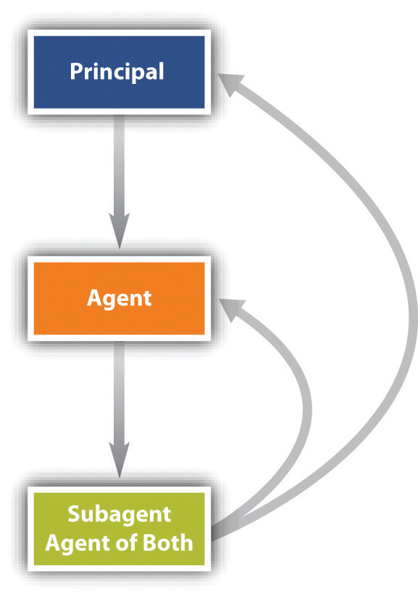

**Servant**

The final category of agent is the servant. Until the early nineteenth century, any employee whose work duties were subject to an employer’s control was called a servant; we would not use that term so broadly in modern English. The Restatement (Second) of Agency, Section 2, defines a servant as “an agent employed by a master [employer] to perform service in his affairs whose physical conduct in the performance of the service is controlled or is subject to the right to control by the master.”

**Independent Contractor**

Not every contract for services necessarily creates a master-servant relationship. There is an important distinction made between the status of a servant and that of an independent contractor. According to the Restatement (Second) of Agency, Section 2, “an independent contractor is a person who contracts with another to do something for him but who is not controlled by the other nor subject to the other’s right to control with respect to his physical conduct in the performance of the undertaking.” As the name implies, the independent contractor is legally autonomous. A plumber salaried to a building contractor is an employee and agent of the contractor. But a plumber who hires himself out to repair pipes in people’s homes is an independent contractor. If you hire a lawyer to settle a dispute, that person is not your employee or your servant; she is an independent contractor. The terms “agent” and “independent contractor” are not necessarily mutually exclusive. In fact, by definition, “… an independent contractor is an agent in the broad sense of the term in undertaking, at the request of another, to do something for the other. As a general rule the line of demarcation between an independent contractor and a servant is not clearly drawn.”1. *Flick v. Crouch*, 434 P.2d 256, 260 (OK, 1967).